Photo-switching of Motor Proteins toward Smart Molecular Systems

Nobuyuki Tamaoki
Research Institute for Electronic Science (RIES), Hokkaido University, Kita 20, Nishi 10, Kita-ku, Sapporo, Hokkaido, 001-0020, Japan. E-mail: tamaoki@es.hokudai.ac.jp; Fax: +81-11-706-9357; Tel: +81-11-706-9

We as a higher form of life with the brain and nerves show a kind of smartness, exemplified by our proper actions taken after the consideration of various conditions of our circumstances. But it is also known that neither brains nor nerves are necessary for some simple smartness. Euglena, a typical single cellular form of life, can sense the difference in wavelength or intensity of light and tend to swim toward a green light escaping from an intense blue light by using its flagella. Now we can set a question: what are the minimum requisites in the substances for actualizing such smartness as shown by euglena? Is it possible to construct such a smart system from molecules? We tried to construct smart molecular systems that can see, make judgements and take suitable actions by the combination of motor proteins and synthesized molecular photoswitches.
First we studied the possibility of the repeated ON-OFF photo-regulation of the motile function of kinesin, one of the important linear motor proteins transporting nano-scale objects along microtubules within cells. For the purpose we introduced a photoresponsive azobenzene into a mono-molecular layer under kinesins or into an energy molecule used instead of ATP¹ or into an inhibitor of the hydrolysis reaction of ATP. It was first demonstrated that a non-nucleoside azobenzene triphosphate supported the kinesin-microtubule motility. And the reversible photoisomerization of the energy molecule by UV and visible lights induced the change with 79% difference in the motile speed of kinesin-microtubule. Using the photoresponsive inhibitor, azobenzene-peptide, the gliding velocity of the microtubules driven by kinesin and ATP could be repeatedly controlled between completely stopped and high-speed states by irradiation with visible and UV light, respectively.
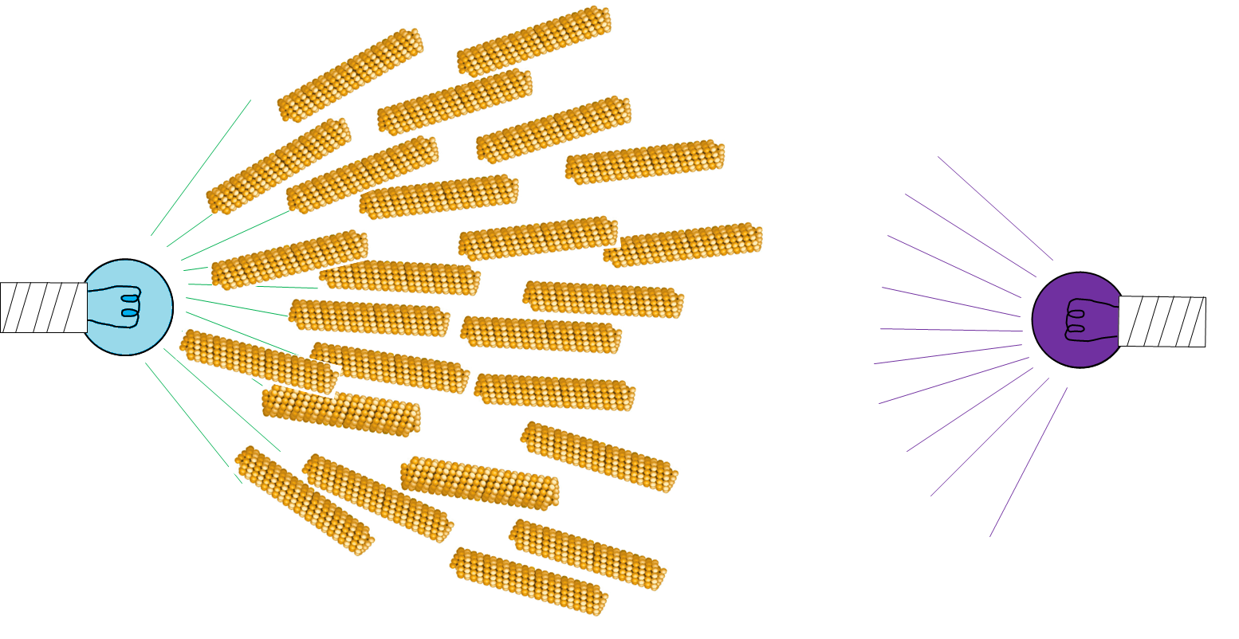
Fig.1 The phototaxis was demonstrated with an artificially constructed molecular system. Rods represent microtubules. Microtubules escaped from UV light and gathered to blue light.

When we irradiate the kinesin-microtubule- ATP system containing the photoresponsive inhibitor with UV and visible lights, microtubules show the movement in the UV-irradiated area and stopped motion in the visible light area. And microtubules finally gathered at the visible light area. This phenomenon can be considered as the phototaxis demonstrated with an artificially constructed molecular system.

Reference
- N. Perur, M. Yahara, T. Kamei, N. Tamaoki, Chem. Commun, 2013, 49, 9935-9937.

